Use Translate Package

from translate import Translator

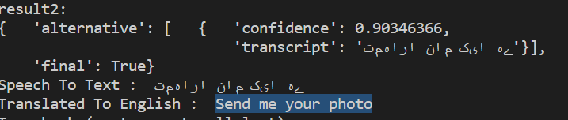

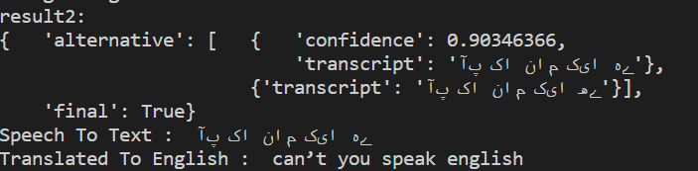

Use GoogleTrans package

from googletrans import Translator

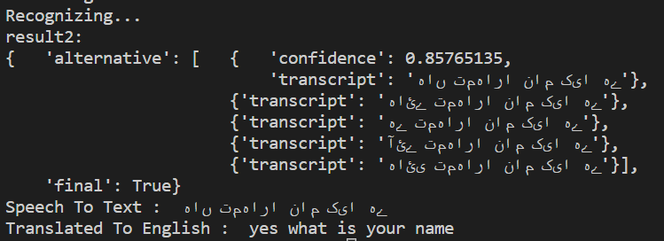

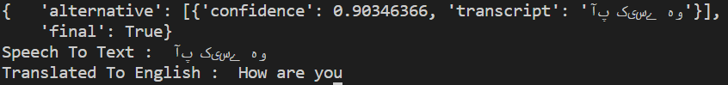

GoogleTrans Package is good for max translation